

**Name: Esha Shahzad**

**Sapid: 55593**

**Course: Coal Lab**

**Instructor: Mam Fareeha**

**Task # 1:** **Write an assembly language program that find the square of a number entered by user. Print the result on screen.**

org 100h

.model small

.stack 100h

.data

msg db 'The square of the number is: $'

result db 0

.code

main proc

mov ah, 01h

int 21h

sub al, 48

mov bl, al

mov al, bl

mul bl

mov result, al

mov ah, 09h

lea dx, msg

int 21h

mov dl, result

add dl, 48

mov ah, 02h

int 21h

mov ax, 4C00h

int 21h

main endp

end main

**OUTPUT:**

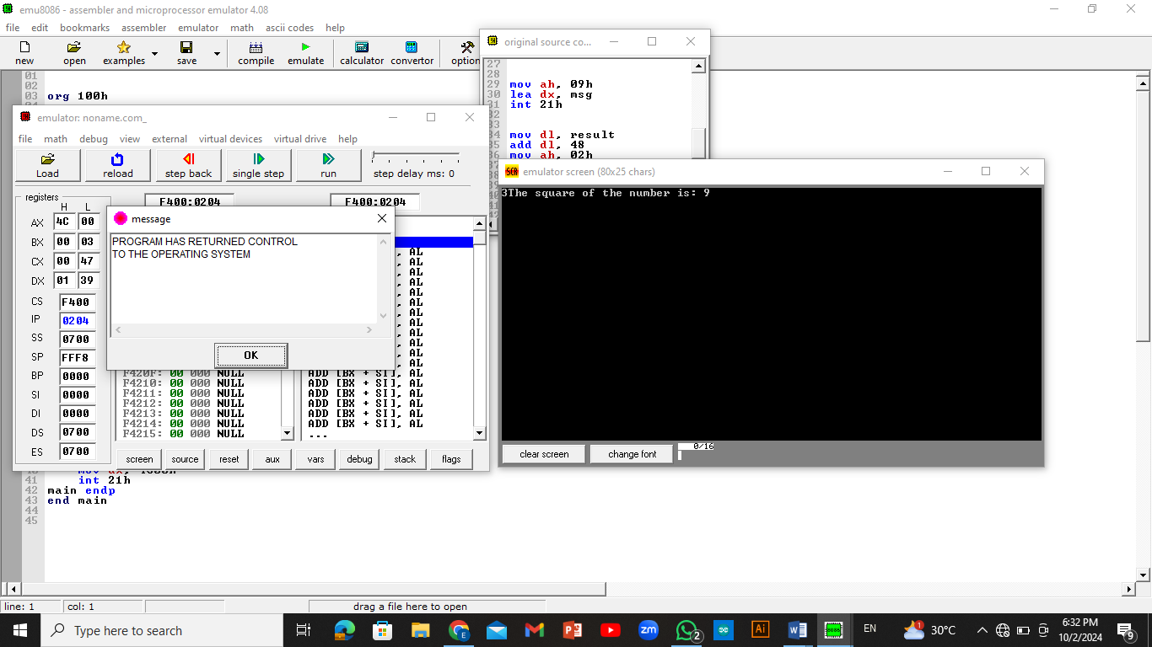

**Task#2: Write an assembly language program that find the cube of a number entered by user. Print the result on screen.**

.model small

.data

.code

main proc

mov ah,1

int 21h

sub al,48

mov bl,al

mul bl

mul bl

AAM

mov ch,ah

mov cl,al

mov dl,ch

add dx,48

mov ah,2

int 21h

mov dl,cl

add dx,48

mov ah,2

int 21h

mov ah,4ch

int 21h

main endp

end main

**OUTPUT:**

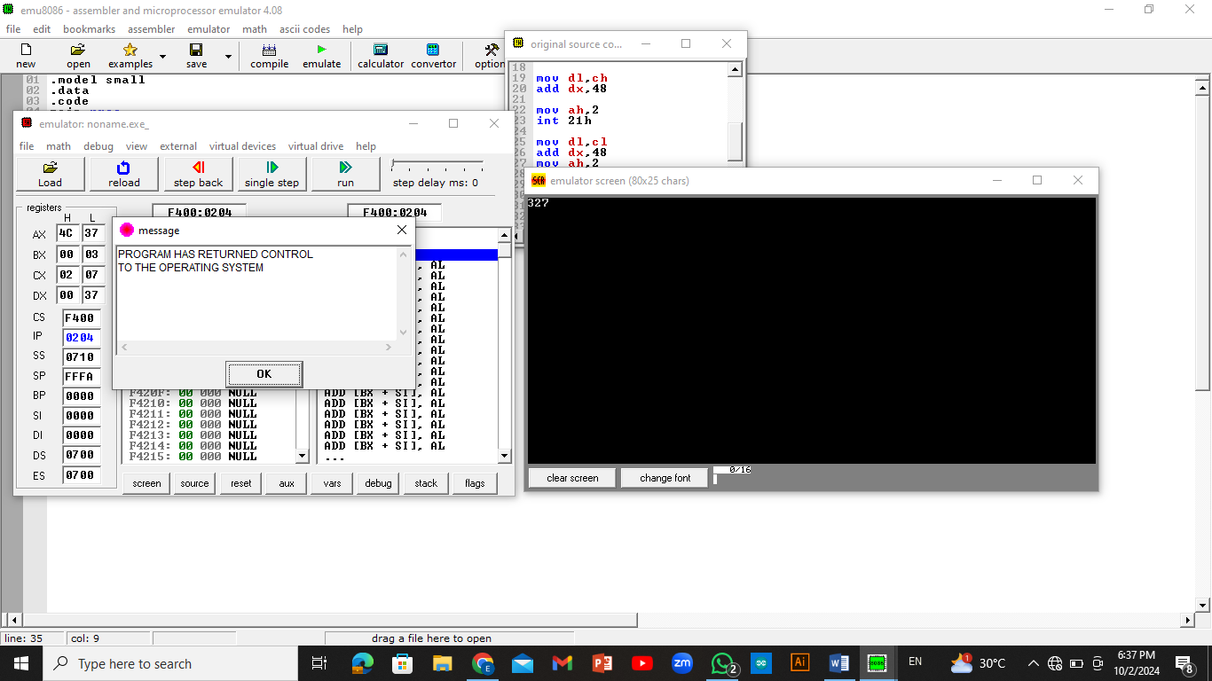

**Task#3: Perform multiplication of two numbers entered by user. Print the result on screen.**

.model small

.stack 100h

.data

num1 db

.code

main proc

mov ah,01

int 21h

sub al,48

mov bl, al

mov dl,'*'

mov ah,02

int 21h

mov ah,01

int 21h

sub al,48

mul b

AAM

mov ch,ah

mov cl,al

mov dl,ch

add dx,48

mov ah,2

int 21h

mov dl,cl

add dx,48

mov ah,2

int 21h

mov ah,4ch

int 21h

main endp

end main

**OUTPUT:**

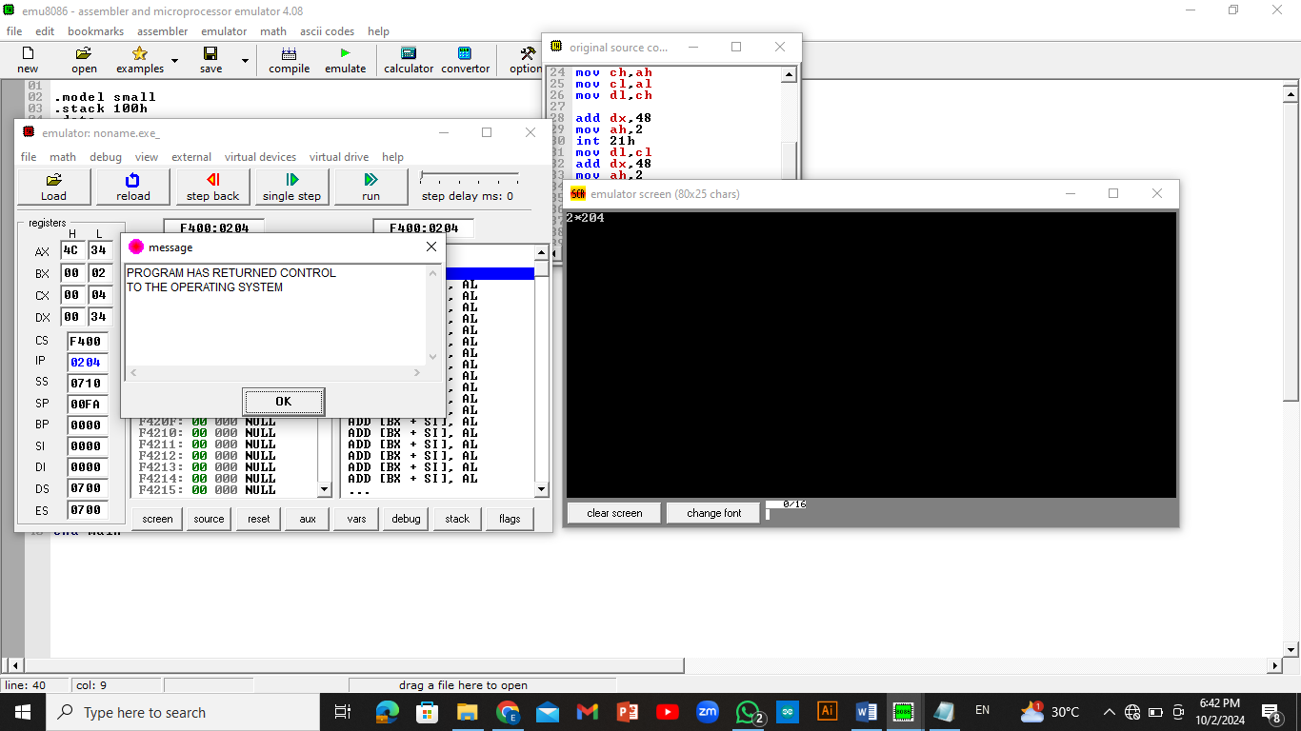

**Task#4: Write an assembly language program that finds the area of a triangle.**

.model small

.stack 100h

.data

msg db 'entre baes= $'

msg1 db 'entre height= $'

msg2 db 'result= $'

.code

main proc

mov ax,@data

mov ds,ax

mov dl,msg

mov dx,offset msg

mov ah,9

int 21h

mov ah,1

int 21h

mov bl,al

sub bl,48

mov dl,10

mov ah,2

int 21h

mov ax,@data

mov ds,ax

mov dl,msg1

mov dx,offset msg1

mov ah,9

int 21h

mov ah,1

int 21h

mov cl,al

sub cl,48

mov dl,10

mov ah,2

int 21h

mov dl,13

mov ah,2

int 21h

mov dl,13

mov ah,2

int 21h

mov ax,@data

mov ds,ax

mov dl,msg2

mov dx,offset msg2

mov ah,9

int 21h

mov al,bl

mov bl,2

mul cl

div bl

mov dl,al

add dl,48

AAM

mov ch,ah

mov cl,al

mov dl,ch

add dl,48

mov ah,2

int 21h

mov dl,cl

add dl,48

mov ah,2

int 21h

mov ah, 4ch

int 21h

main endp

end main

**OUTPUT:**

